Lab 2- IAM policy

* Go to IAM and click on Policies -> Create Policy

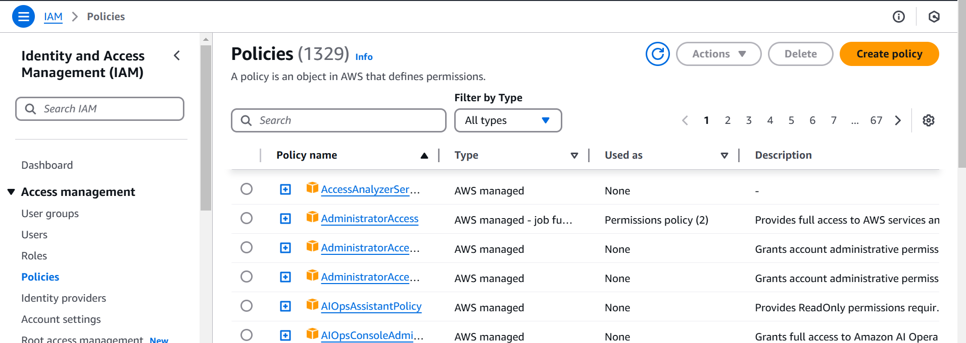

In visual

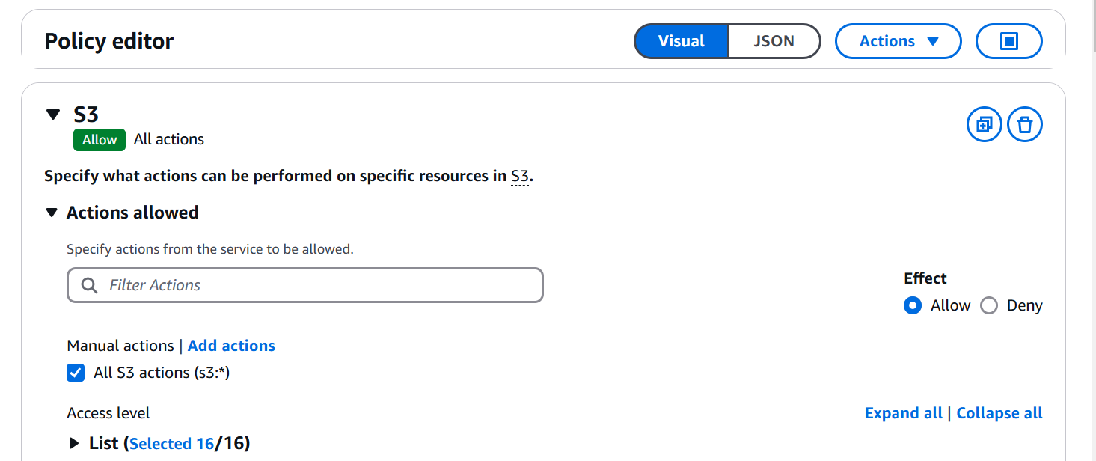

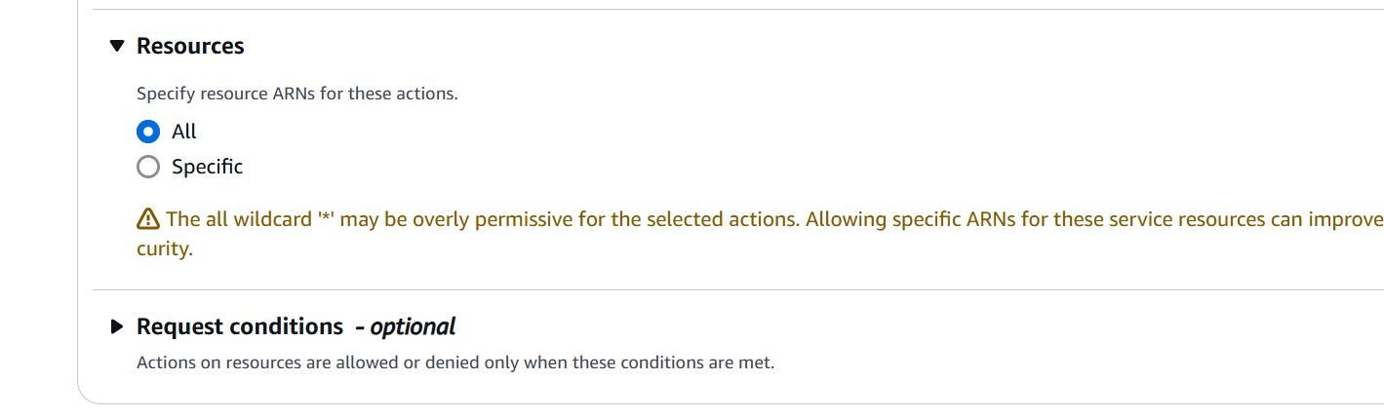

Check json

{

"Version": "2012-10-17",

"Statement": [

{

"Sid": "VisualEditor0",

"Effect": "Allow",

"Action": "s3:\*",

"Resource": "\*"

}

]

}

Provide policy a name and create policy

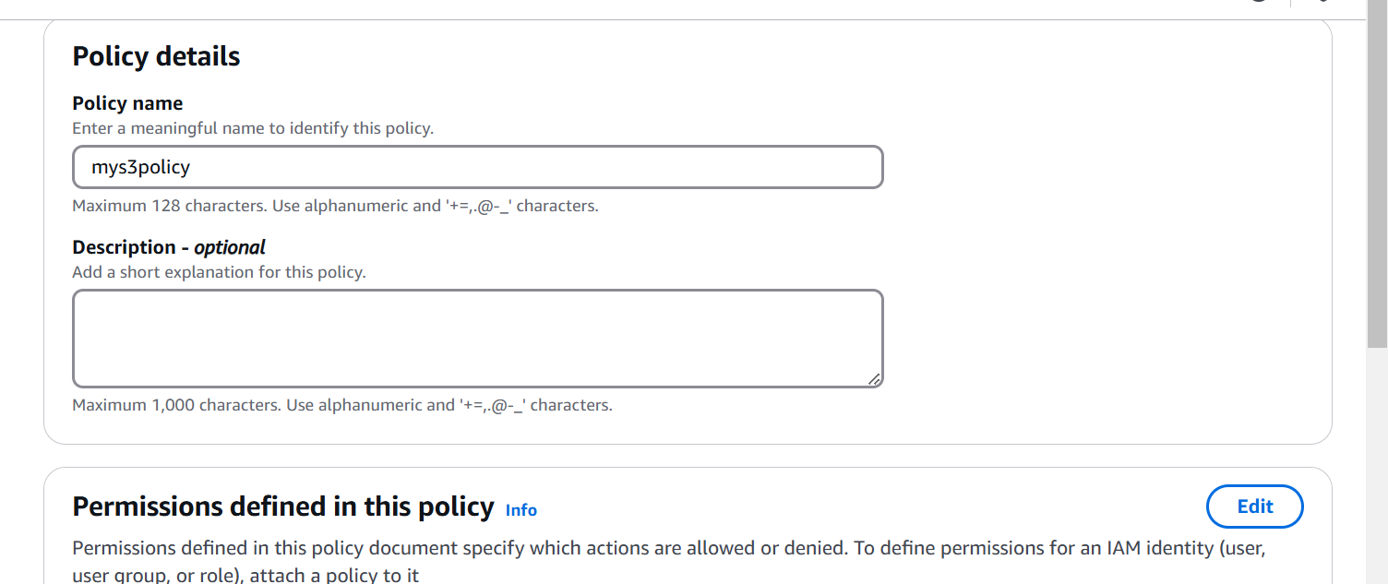

Click on user and click on your user and add permission

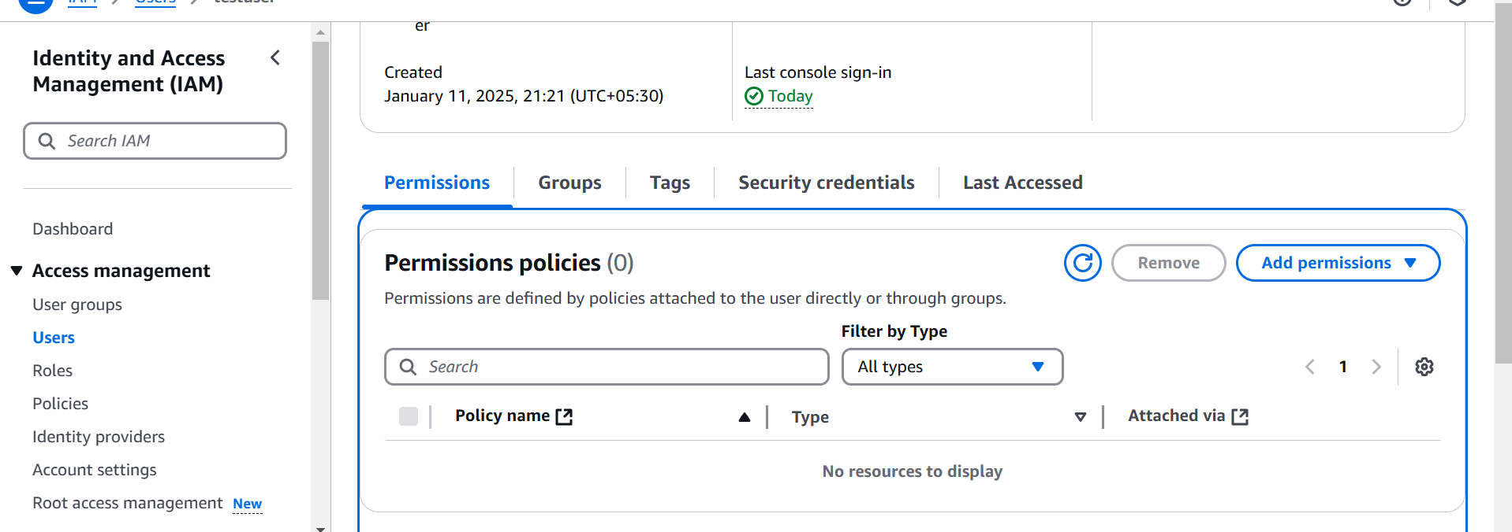

Add Permission

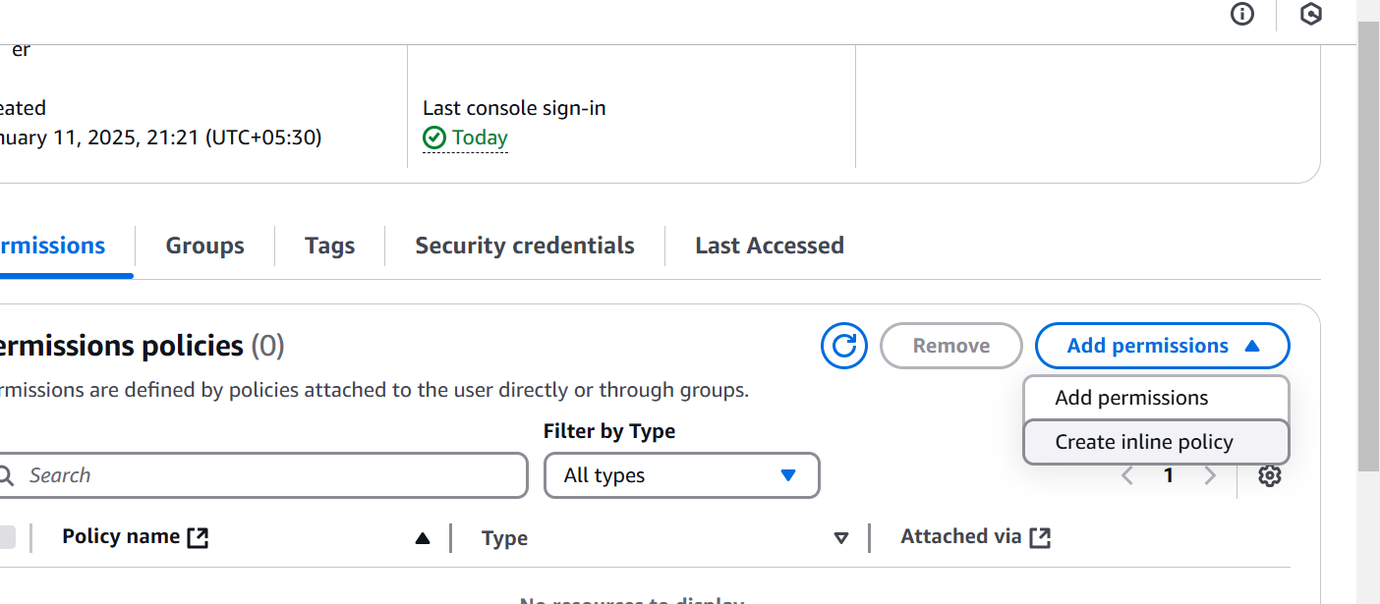

Attach policy directly

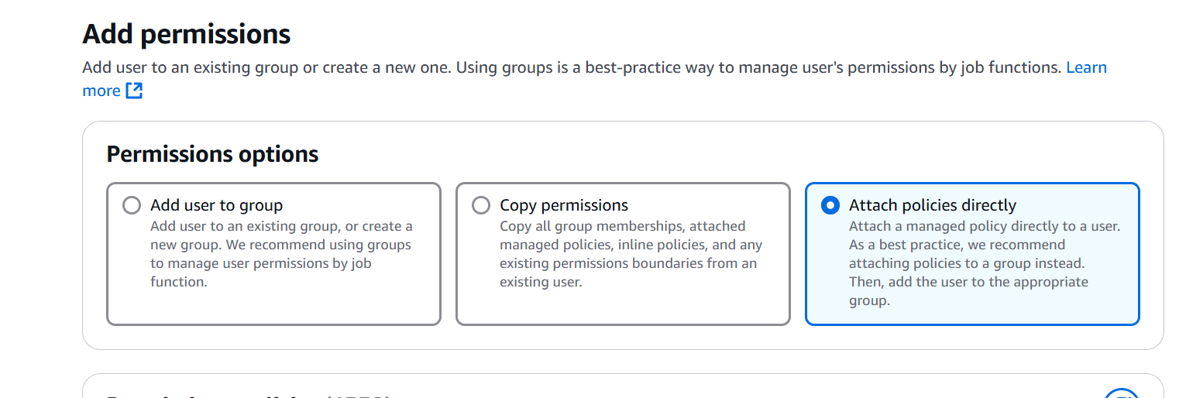

Attach policy

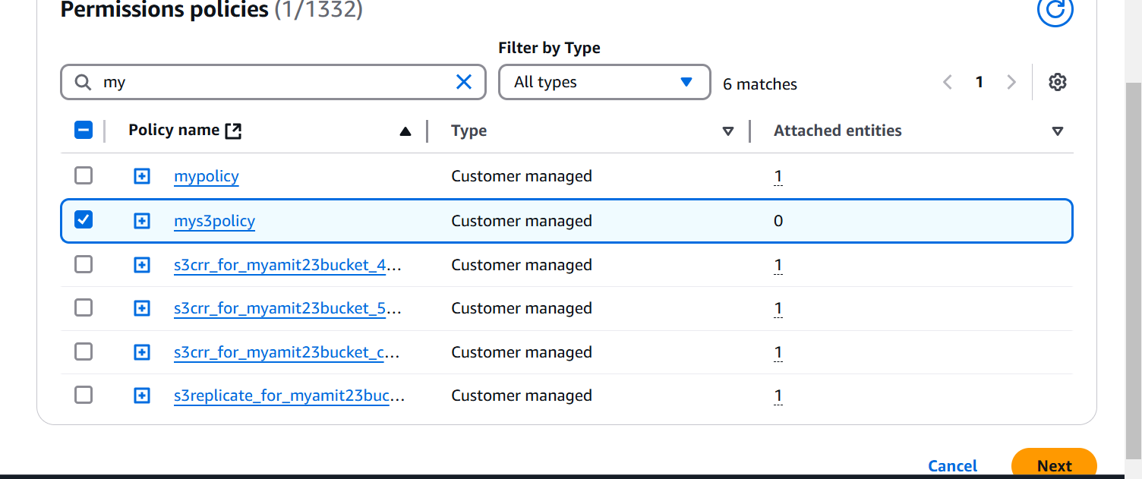

Add permission

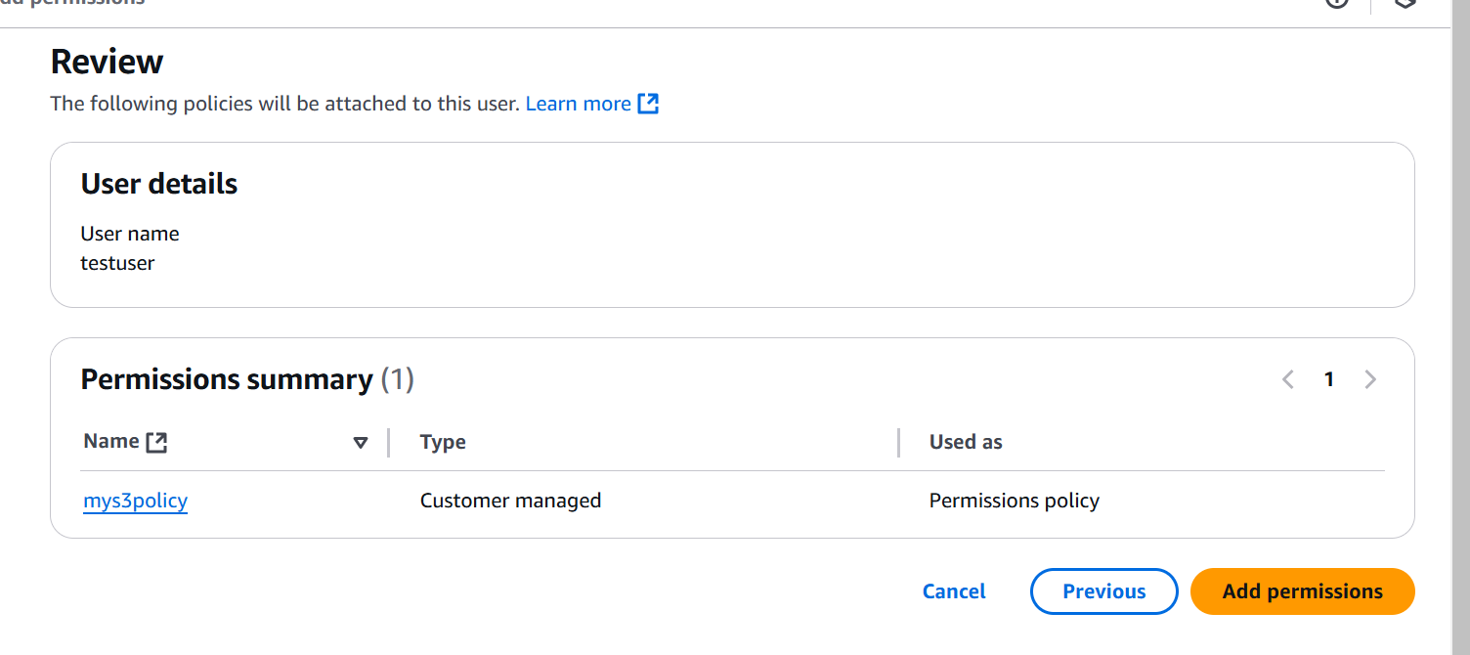

Now go to testuser portal, and check s3 resource